**[Steps to Install and Setup Apache Airflow on Ubuntu 20.04 LTS](https://www.hackerxone.com/2021/10/15/steps-to-install-and-setup-apache-airflow-on-ubuntu-20-04-lts/)**

Apache-Airflow is a free & open source workflow management tool, written in Python. It is used for monitoring the workflow & is a workflow management solutions tool. We can easily visualize the data pipelines’ dependencies, progress, logs, code, trigger tasks, and success status.

There are some steps to install apache-airflow on ubuntu:

Step 1: Update the System.

apt-get update

Step 2: Install the required packages.

apt-get install software-properties-common  
apt-add-repository universe

* Update the packages.

apt-get update

Step 3: Install the python3-pip.

apt-get install python-setuptools  
apt install python3-pip

Step 4: Install the required dependencies for Apache Airflow.

apt-get install libmysqlclient-dev  
apt-get install libssl-dev  
apt-get install libkrb5-dev

pip3 install WTForms==2.3.3

Step 5: Install the Apache-Airflow on system.

* Install the python-virtual Environment.

apt install python3-virtualenv  
virtualenv airflow_example

* Here is the command output.

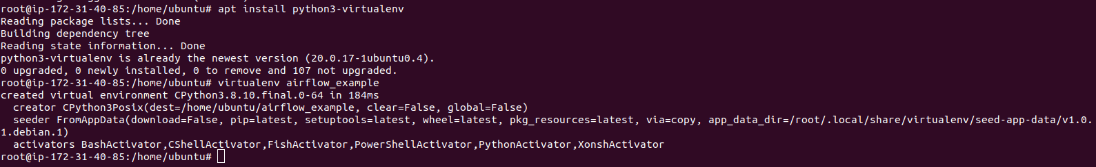

* Change the directory.

cd airflow_example/bin/

* Activate the source.

source activate

* Now ,install the apache-airflow.

export AIRFLOW_HOME=~/airflow  
pip3 install apache-airflow

* Here is the command output.

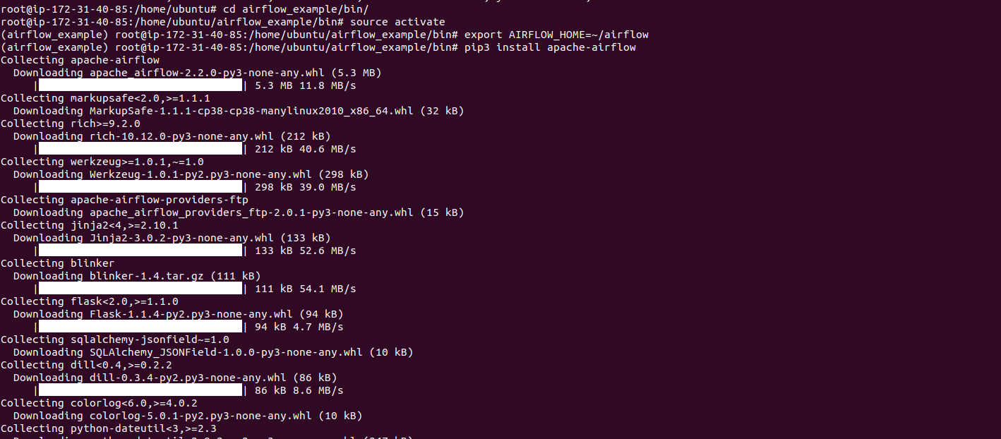

* Install typing_extension.

pip3 install typing_extensions

* Here is the command output.



* Run the following command.

airflow db init

* Here is the command output.

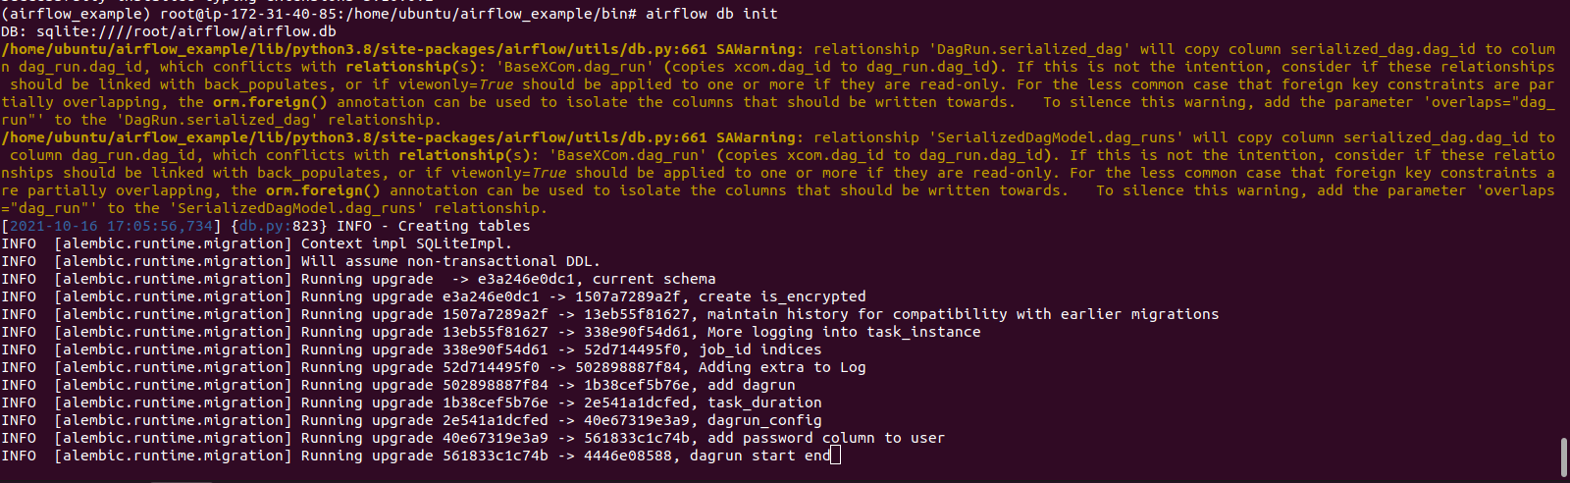

Step 6: Set the Apache-Airflow login credentials for airflow web interface.

airflow users create --username admin --firstname FIRST_NAME --lastname  LAST_NAME --role Admin --email admin@example.org

For example:  
airflow users create --username admin --firstname admin --lastname testing --role Admin --email admin@domain.com

* Here is the command output.

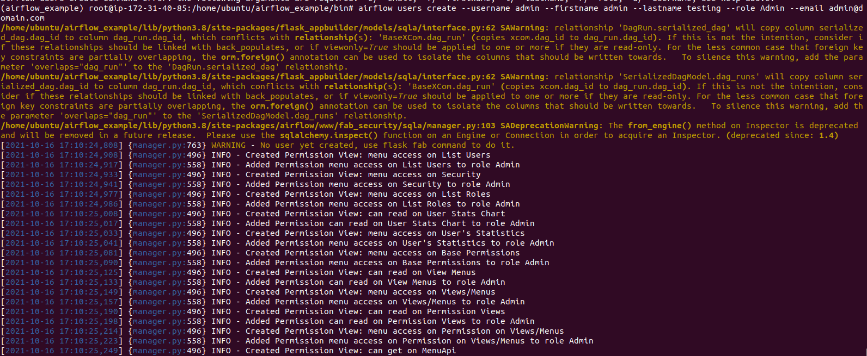

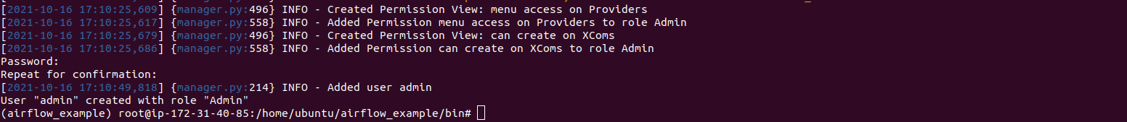

Step 7: Start the Apache-Airflow web interface.

airflow webserver -p 8080

* Here is the command output.

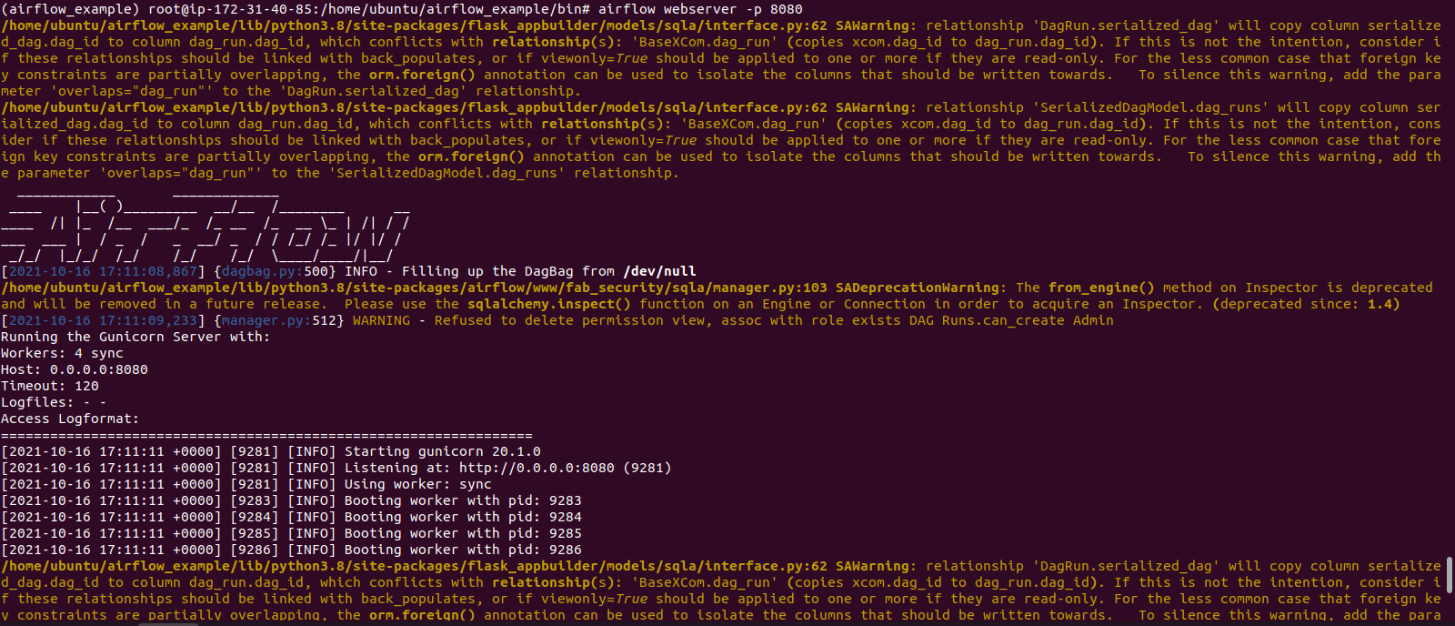

* Without stopping the command,Open the Apache-Airflow web interface using URL.

http://server-ip:8080

* Here is the command output.
* Provide the login credentials like username & password.

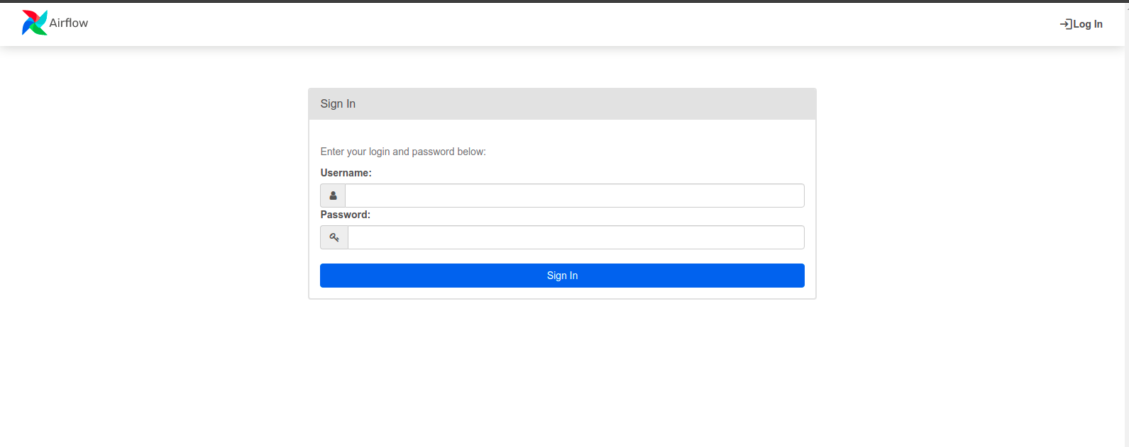

* Now, Apache-Airflow is Ready.

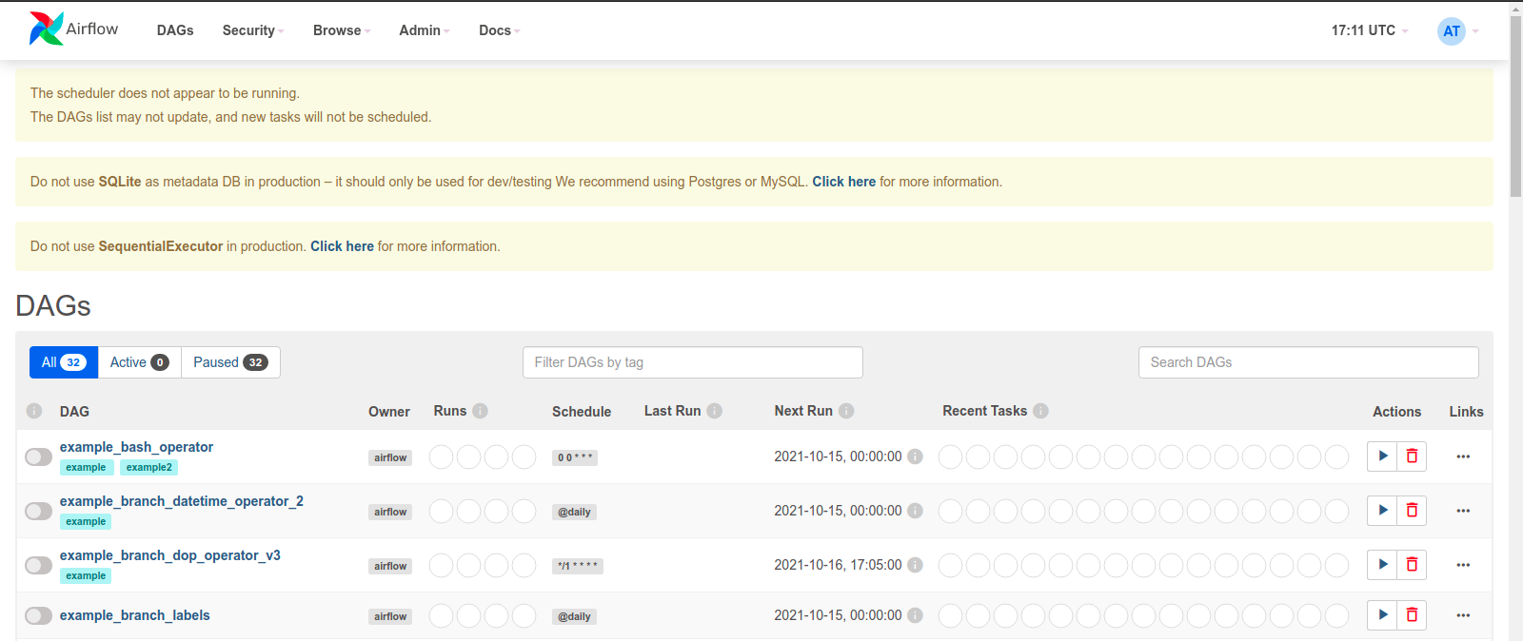

Open new ubuntu tereminal an run

Sudo su and enter password

* Change the directory.

cd airflow_example/bin/

* Activate the source.

source activate

then run

airflow scheduler